Radio West- Interview with Ted Kopple

If the Lights Went Out in America (Nov. 3, 2015)

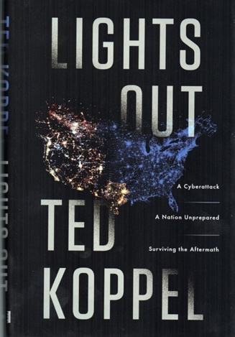

http://radiowest.kuer.org/post/if-lights-went-out-america

